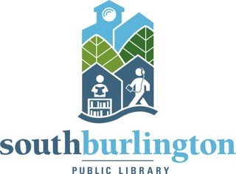**South Burlington Public Library**  **Staff Use Only:**

**Volunteer Interest Form** Date form recv’d:

Initial phone call:

Start date:

Task:

Name: _______________________________________________________________________

Address: _____________________________________________________________________

Phone: _______________________________ E-mail: _______________________________

Date of birth: _________________ (if under 18)

Emergency contact & phone: ____________________________________________________

Parental signature*: ___________________________________________________________ **\***For volunteers under 18 years old; volunteers must be at least 14 years old.

Please list type of volunteer work you would (or specifically would NOT) be interested in: (Tasks may include searching for books, shelf reading, book covering & repair, helping with programs, tech help, and other projects as they come up)

_____________________________________________________________________________

_____________________________________________________________________________

Any special skills or great ideas for programs you’d like to implement?

_____________________________________________________________________________

When are you available to volunteer?

Days/Times Weekly, periodic, seasonal?

_____________________________________________________________________________

Thank you for your interest! We will be in touch with you soon!

**FORM A** rev. 12/5/22